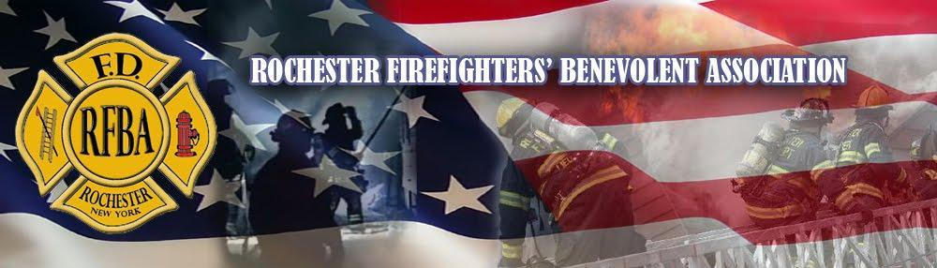
2024
Rochester Firefighters’ Benevolent Association
Scholarship Program
__________________________________________________________________
The Rochester Firefighters’ Benevolent Association is interested in assisting 2024 graduating high school seniors in securing the advantages of post secondary/college education. The Association will award two scholarships per year: A $1000 scholarship will be awarded to two separate students scheduled to attend an accredited post secondary Institution/College/University. These scholarships will be awarded to students demonstrating scholastic aptitude and good citizenship.
APPLICATION MUST BE RECEIVED NO LATER THAN MAY 15, 2024

Rules governing scholarship assistance are as follows:
- No distinction as to race, color, creed, sex, rank of parent/grandparent/legal guardian, association with RFBA, City of Rochester or Local Union shall be drawn in granting of scholarship.
- Applicants must have a parent, grandparent or legal guardian who is a member in good standing with the Rochester Firefighters’ Benevolent Association.
- The candidate must be a graduating High School Senior in 2024.
- The candidate must be accepted at an accredited post secondary institution.
- No assistance will be provided to any student who is already receiving or anticipates receiving a fully paid scholarship, grant or financial aid package. (Not including repayable loans)
- No request for assistance will be considered until the candidate has provided a complete application. Failure to complete the application in full and submit by deadline will result in disqualification.
- Scholarships will be paid directly to the college/institution that the applicant will be attending and are to be used towards school related expenses such as tuition, room and board.
- Scholarships will be made payable upon receipt of the student’s ID and a copy of the students deposit from the college bursar's office. All scholarships are a onetime payment for the first year of attendance.
- Completed applications must be returned to: (Deadline May 15, 2024)

RFBA Scholarship Program
P.O. Box 31764
Rochester NY, 14603

2024 RFBA Scholarship Winner Selection Process

- All RFBA Scholarship applications will be received by the RFBA Secretary and reviewed for completeness.
- The RFBA Secretary will copy all applications and required material removing names and assigning a number to each applicant’s submission.
- Each application and related material will be reviewed by the RFBA Scholarship selection committee and the winners will be picked anonymously. Only the RFBA Secretary will know who submitted each application and will not be part of the selection committee.
- The winning scholarships will be based on scholastic aptitude, goals and good citizenship.
- Once the winning applications are selected the applicants will be notified and awarded the scholarships, by July 15, 2024, at which time arrangements will be made to send the funds to the institution to which they are enrolled.

COMPLETE APPLICATIONS AND ALL REQUIRED MATERIALS MUST BE RECEIVED NO LATER THAN MAY 15, 2024

RFBA Scholarship Program
P.O. Box 31764
Rochester NY, 14603

2024 Rochester Firefighters’ Benevolent Association Scholarship Program Application

Name______________________________________________________________________
(Last) (First) (Middle)

Address____________________________________________________________________

____________________________________________________________________

Telephone Number_________________________________________

High School Currently Attending_______________________________

Anticipated HS Graduation Date_______________________________

College/Institution you will be attending____________________________________________

Intended College Major_________________________________________________________

Sponsoring RFBA Member’s Name_______________________________________________

On separate paper answer the following two questions in short essay form. (Please type or print your answers.)

- Describe your extracurricular activities in and/or out of school. Please be specific and include sports, clubs, volunteer work...also include any awards you may have received. (500 words or less)
- What is your ambition in life and what are your educational and personal goals? (500 words or less)

***Also include an OFFICIAL copy of your High School Transcript and an OFFICIAL copy of your SAT and/or ACT scores with the application.

I hereby declare that all information that I have provided is truthful and accurate to the best of my knowledge.

_______________________________ _________________________________
(Student Applicant’s Signature) (Name of RFBA Member: Parent/
Grandparent/Legal Guardian)

_______________________________ _________________________________
(Applicant’s Telephone #) (RFBA Member’s Telephone #)

Completed applications and all required material must be received by May 15, 2024.
RFBA Scholarship Program
P.O. Box 31764
Rochester NY, 14603

